**Unit 2 – Math in Compounds**

1. **Molar Mass**- The mass of an individual molecule or formula unit.

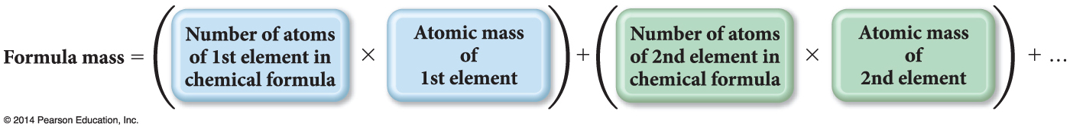

*Find the molar mass of Na2SO4*

2. **Percent by Mass**- Percentage of each element in a compound

Can be determined from

the formula of the compound and

the experimental mass analysis of the compound.

The percentages may not always total to 100% due to rounding.



*What is the percent of C & H in C2H6?*

3. **Empirical Formula**

Simplest, whole-number ratio of the atoms of elements in a compound

Can be determined from elemental analysis

* + Masses of elements formed when a compound is decomposed, or that react together to form a compound

Combustion analysis

* + Percent composition

**Note**: An empirical formula represents a ratio of atoms or a ratio of moles of atoms, *not a ratio of masses*.

***Procedure***

1. Convert the percentages to grams.

a) Assume you start with 100 g of the compound.

b) Skip if already grams.

2. Convert grams to moles.

a) Use molar mass of each element.

3. Write a pseudoformula using moles as subscripts.

4. Divide all by smallest number of moles.

a) If the result is within 0.1 of a whole number, round to the whole number.

5. Multiply all mole ratios by a number to make all whole numbers.

* 1. If ratio .5, multiply all by 2.
  2. if ratio .33 or .67, multiply all by 3.
  3. If ratio 0.25 or 0.75, multiply all by 4, etc.

d) Skip if already whole numbers.

*Find the empirical formula given: 65.2% Sc and 34.8 % O*

4. The molecular formula is a multiple of the empirical formula.

To determine the molecular formula you need to know the empirical formula and the molar mass of the compound.

Molecular formula = (empirical formula)n, where n is a positive integer.

The molar mass is a whole-number multiple of the empirical formula molar mass, the sum of the masses of all the atoms in the empirical formula:

n = molar mass

empirical formula molar mass

*The empirical formula of a compound is CH4. It has been determined that a molecule’s MM is 32g. What is the molecular formula?*

5. The percentage purity of a solid can be calculated as follows:

Percentage purity = mass of the pure product x 100

mass of whole impure

the higher the % purity, the closer the solid is to a pure substance.

If a 5.00 g sample of iron ore contains 0.25 g of iron metal, what is the percent purity?